Оглавление

ATSAMD21G18A(ZERO) 2

ATmega328P(NANO) 4

# ATSAMD21G18A(ZERO)

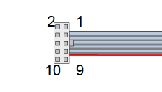

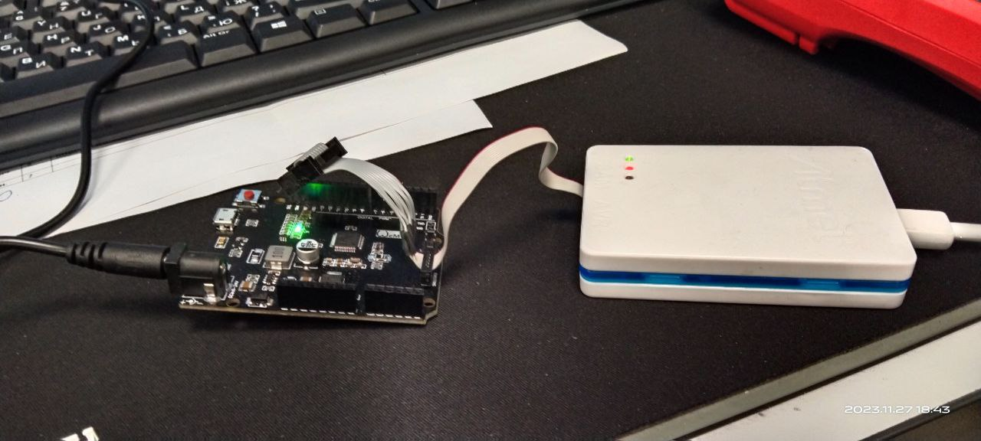

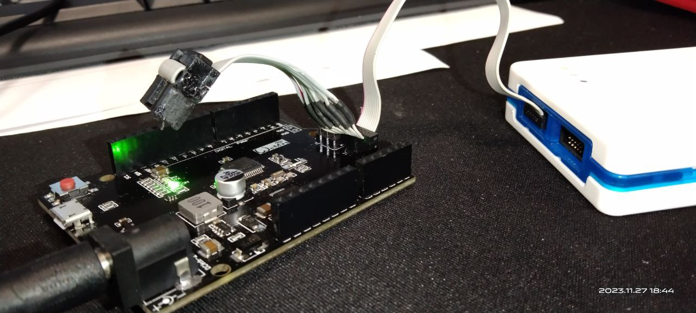

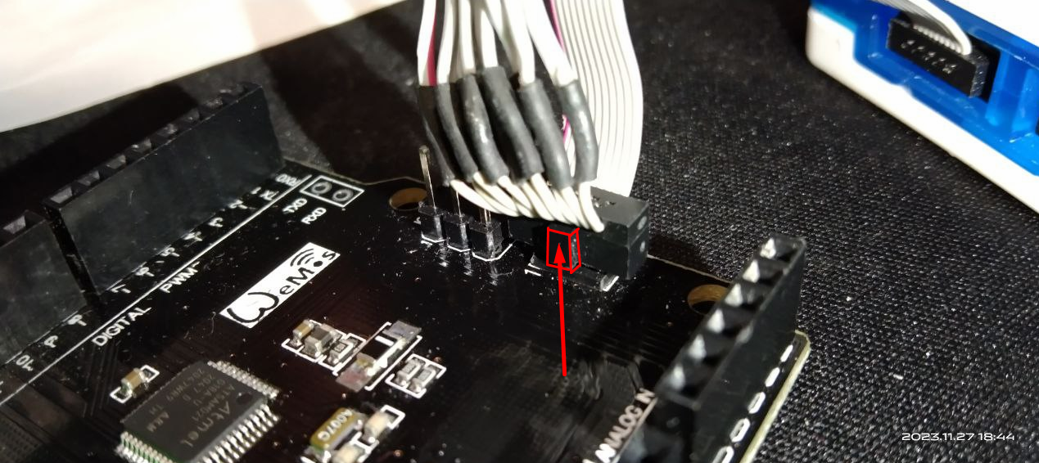

[https://store.arduino.cc/products/arduino-zero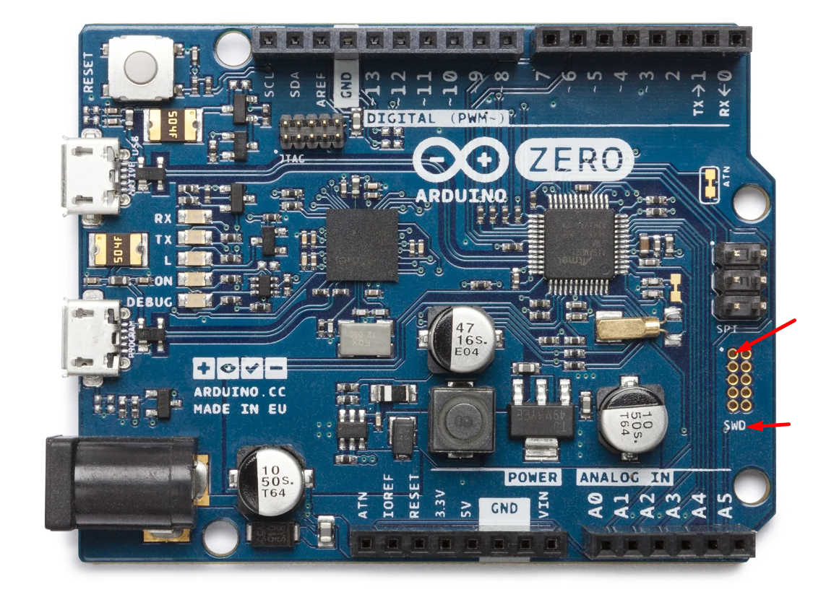](https://store.arduino.cc/products/arduino-zero)

<https://store.arduino.cc/products/arduino-zero>

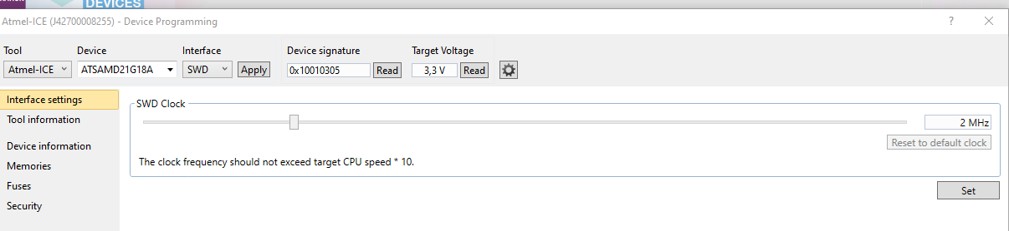

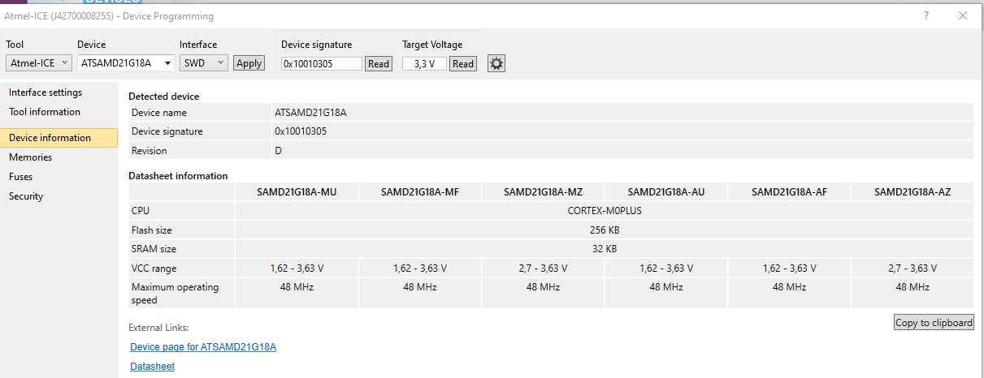

# ATmega328P(NANO)

